Web Browser Client Certificate Installation for JAB online VoIP Provisioning

Beginning 6/8/2009 a Client SSL Certificate will be required to access the JAB online VoIP provisioning portal. Client SSL certificates will be issued to authorized users using company owned computers that meet the minimum requirements for VoIP provisioning.
This is a security measure to ensure that provisioning credentials are not entered on un-trusted computers that could be infected with spyware or a virus, compromising VoIP network security and customer privacy, and creating a financial risk through unauthorized use of VoIP service.
System requirements;
Computer: JAB company owned computers only, personal computers will not be authorized.
OS: Microsoft Windows XP Professional, Microsoft Windows Vista Business, Microsoft Windows Vista Ultimate, Mac OSX.
Anti-Virus/Anti-Spyware: McAfee, Symantec, Trend Micro, or other company approved commercially supported anti-virus software that incorporates spyware detection, real-time scanning, and daily automatic updates.
Web Browser: Microsoft Internet Explorer 7.0 or later on Windows, Mozilla Firefox 3 or later on Mac OSX
The following instructions were created on a Windows Vista Computer with Internet Explorer 7, however the steps are similar on other versions of windows and Mac OS computers.

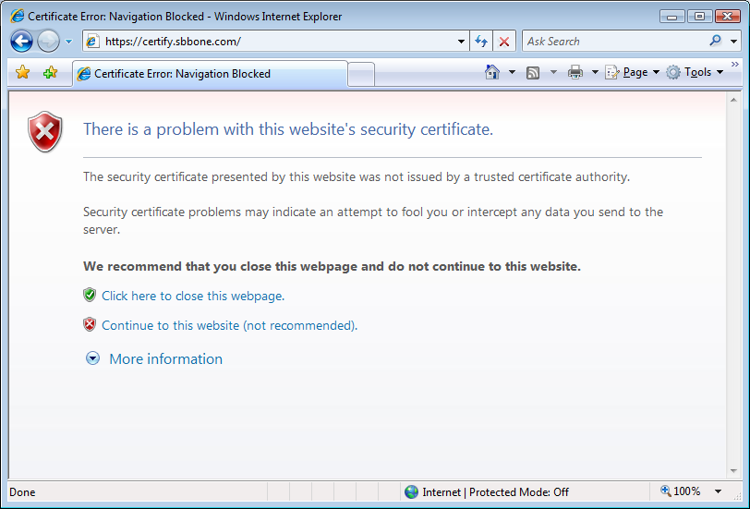
Open the supported web browser that you will use to perform VoIP provisioning tasks. Navigate to https://certify.sbbone.com. You will receive an error about an invalid certificate. this is due to the fact that we have signed our owned certificate, and your computer will not trust the certificate until you have installed the root certificate into the "trusted root certificates store". You will want to continue to the website, ignoring any certificate warnings.

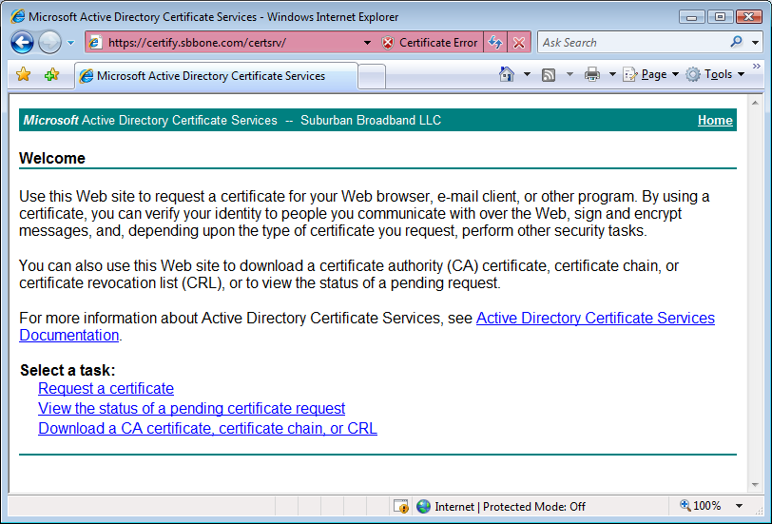
Click on "Download a CA certificate, certificate chain, or CRL"
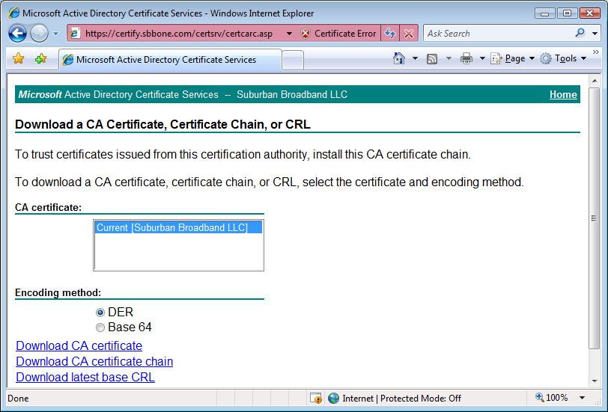
Click "Download CA certificate".

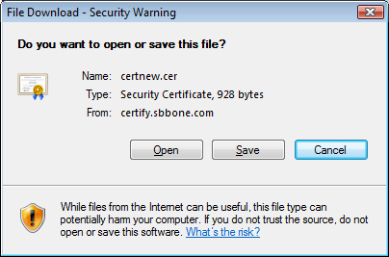
Click "Open".
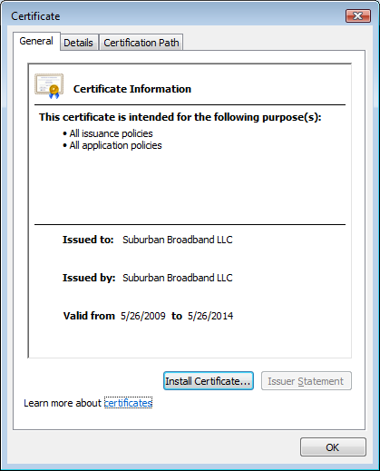
Click "Install Certificate".
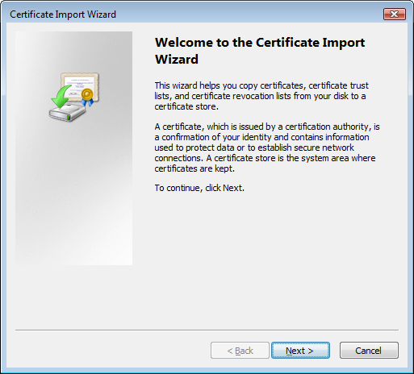
Click "Next".
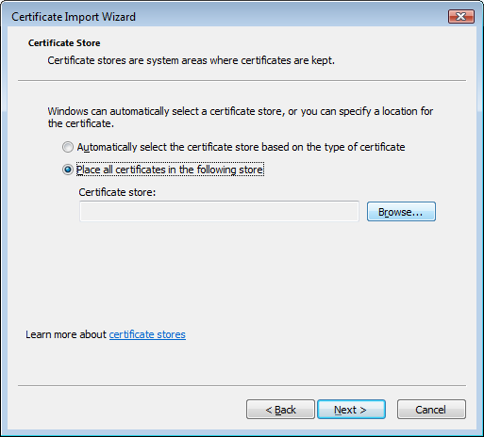
Windows Vista does not correctly place the certificate, select "Place certificates in the following store", then click browse.

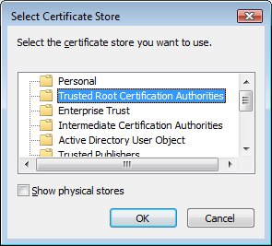
Choose the "trusted Root Certification Authorities". Click OK

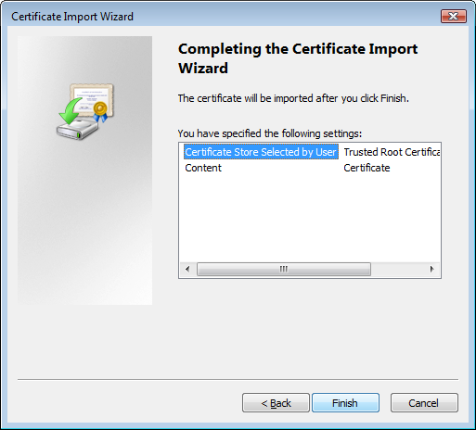
Click "Finish".
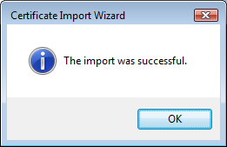
Click "OK".
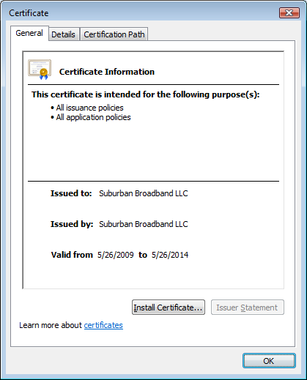
Click "OK".

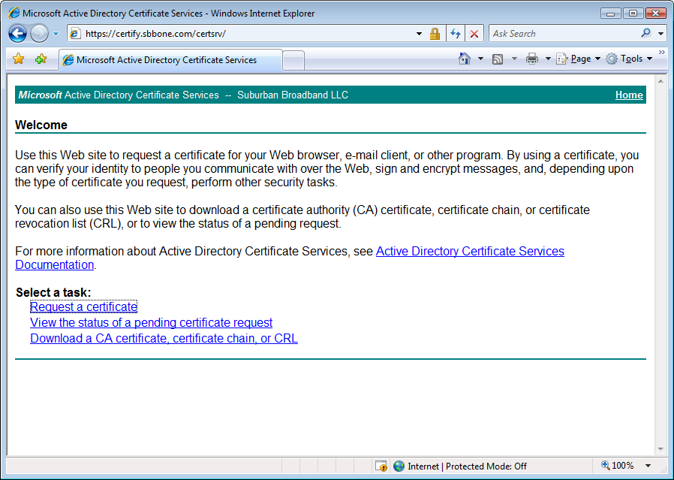
Close your browser, open it again, and navigate to https://certify.sbbone.com. You should not receive any certificate errors. Click "Request a certificate".
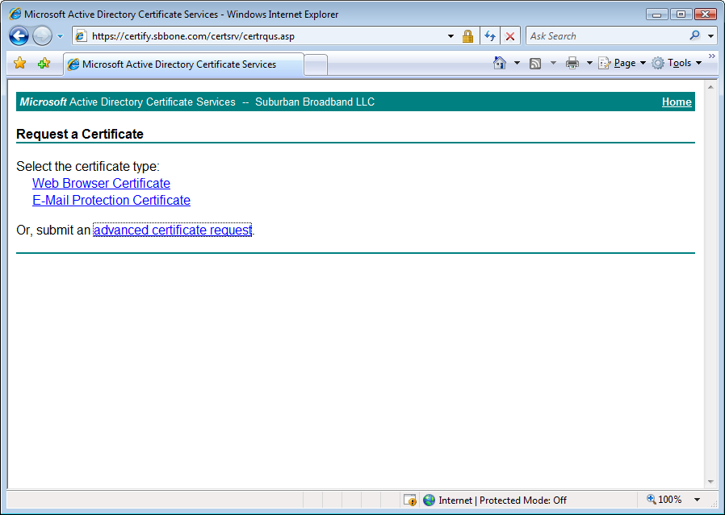
Click "advanced certificate request".
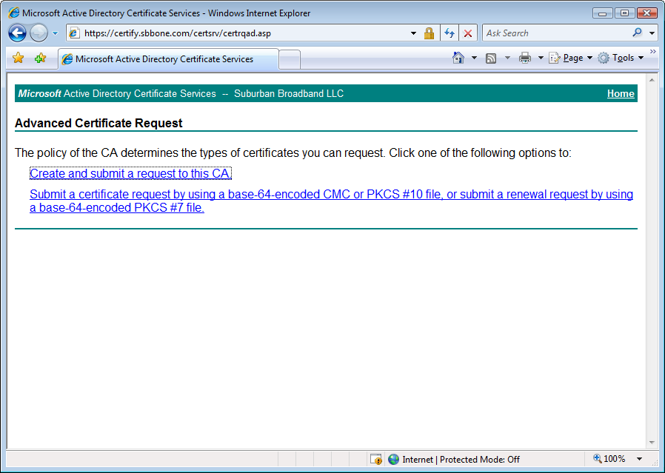
Click "Create and submit a request to this CA".

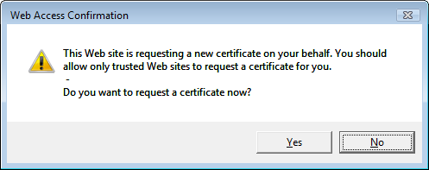
Click "Yes".
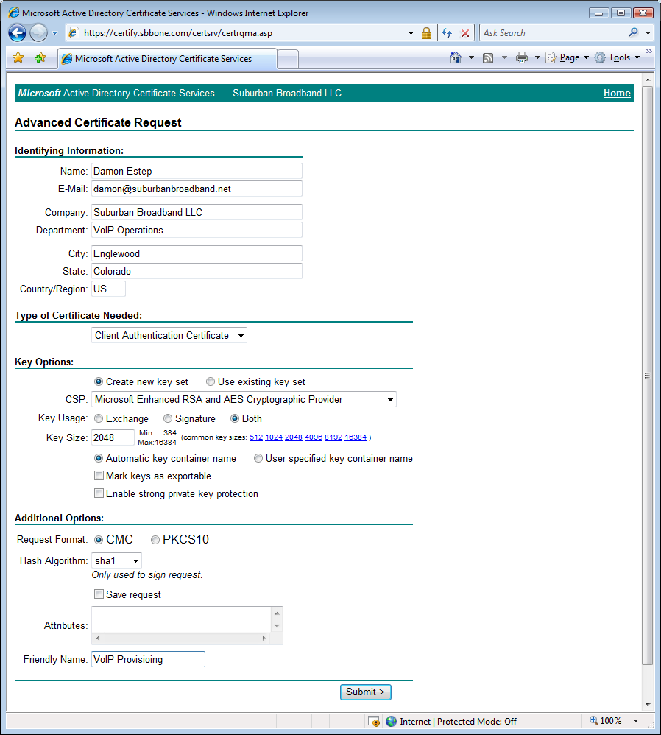
Complete the advanced request form using your identifying information. Note the values for these fields (other fields can be left default as shown above);
Type of Certificate Needed: Client Authentication Certificate
Key Size: 2048
Friendly Name: VoIP Provisioning
Click "Submit".

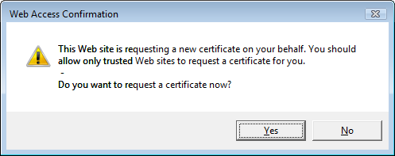
Click "Yes".

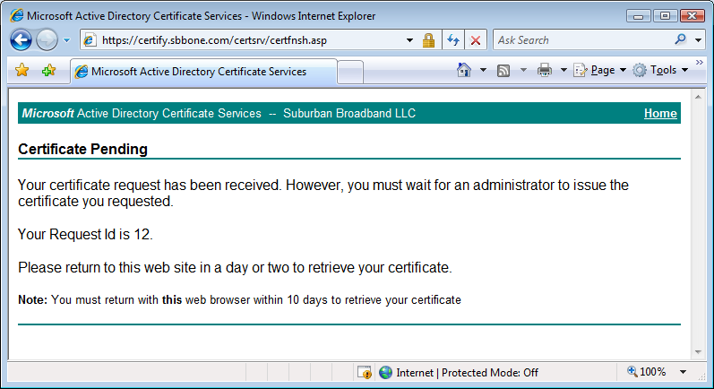
If you see this message you have successfully requested a client certificate. Make a note of the Request ID. Complete the Computer Authorization Request Form, including your request ID form above, and email it to certificates@sbbone.com. Your request will take one business day to process and you will receive notification by email when your client certificate has been issued.
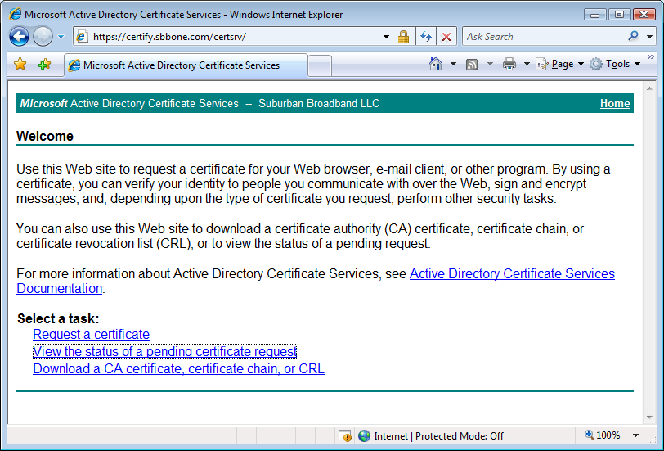
Once you have received notification that your certificate request has been approved and your certificate has been issued, open your browser (must be the same browser on the same computer with the same user logged in as when you submitted the request). Navigate to https://certify.sbbone.com, then select "View the status of a pending certificate request".
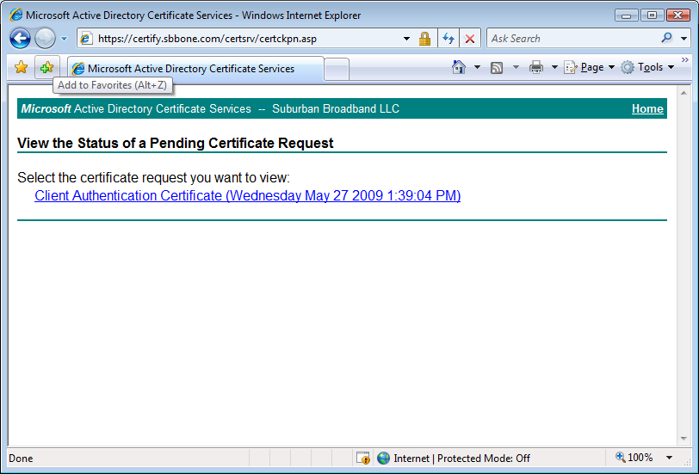
Click on the request your created earlier.
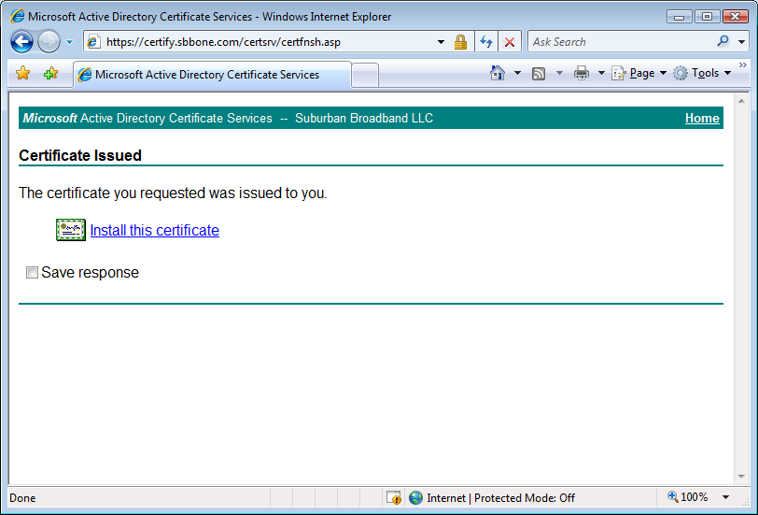
Click "Install this certificate".
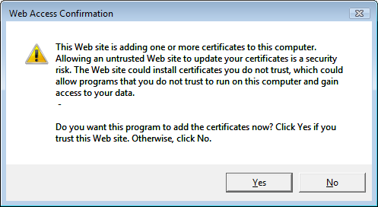
Click "Yes".
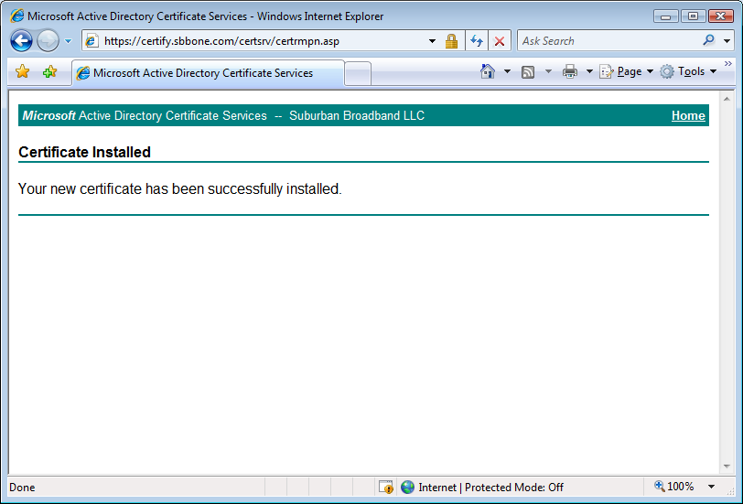
If you see this screen you are almost done!
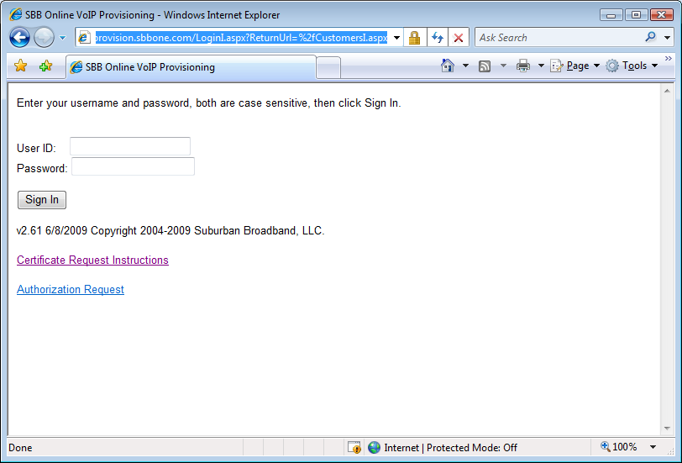
Close and then open your browser, then navigate to https://provision.sbbone.com. If you are using Windows XP, 2003, or Mac OSX you may be presented with a dialog asking which client certificate you wish to use. Select the certificate with a friendly name of "VoIP Provisioning" If you have previously installed client certificate from other sources you may have more than one option. It should be obvious which certificate is required based on the certificate names.
If you are able to access the login page you are done, if not please email any details of the errors you encountered to certificates@sbbone.com.

